CN Lab 3:
24k-0810
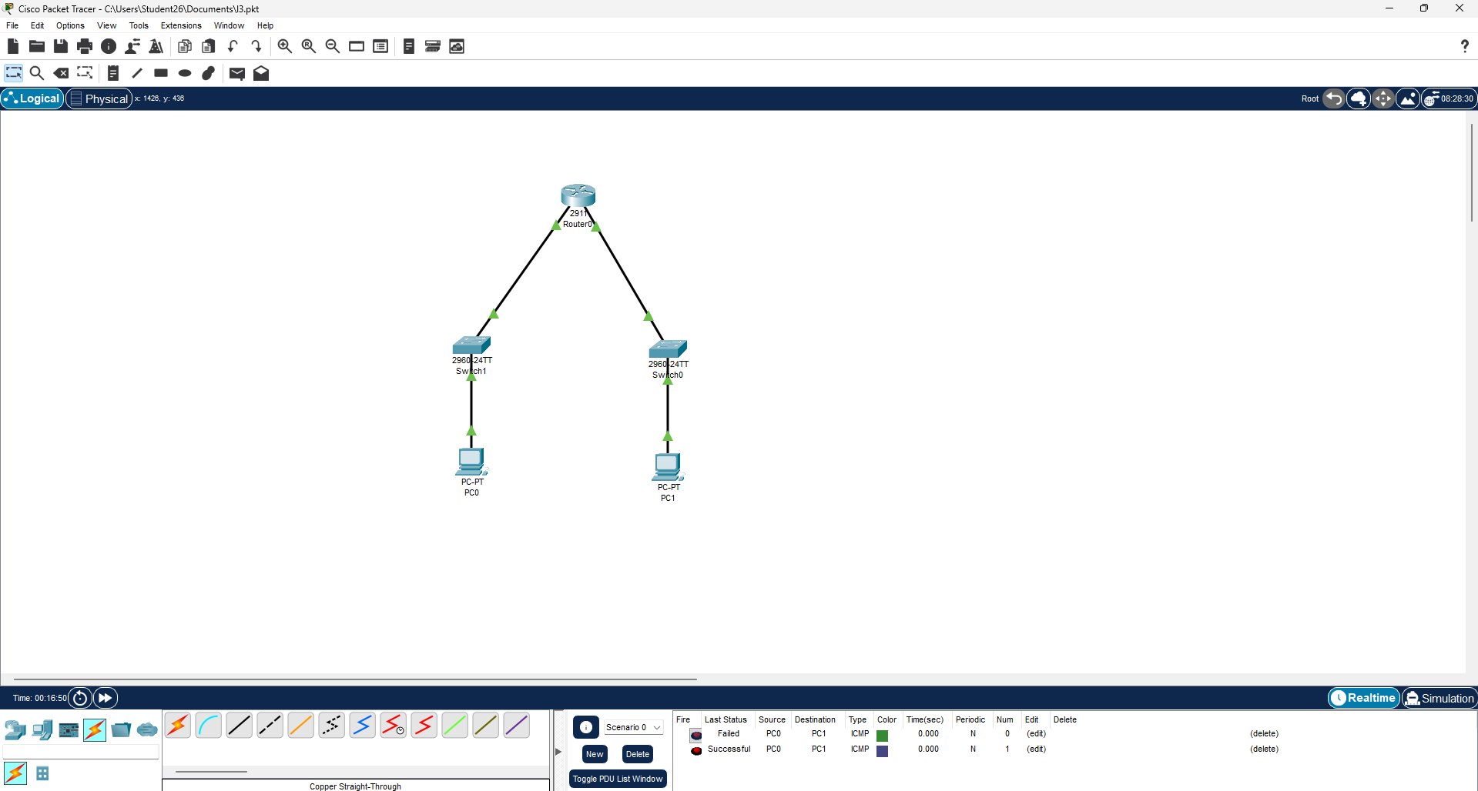

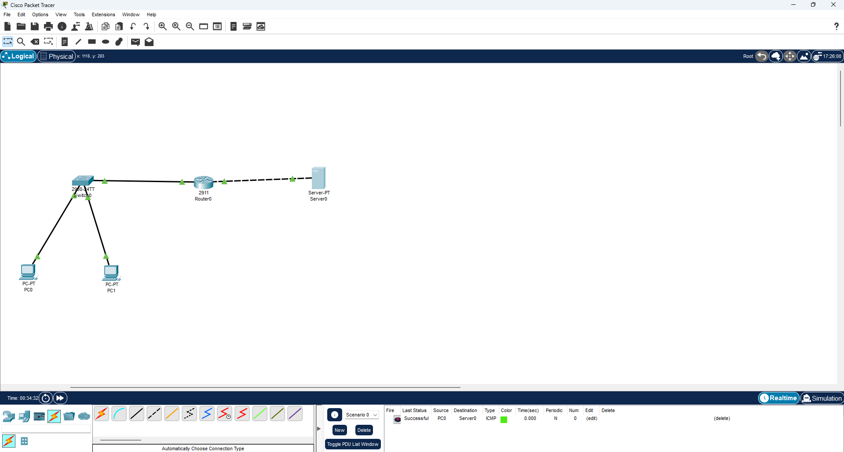
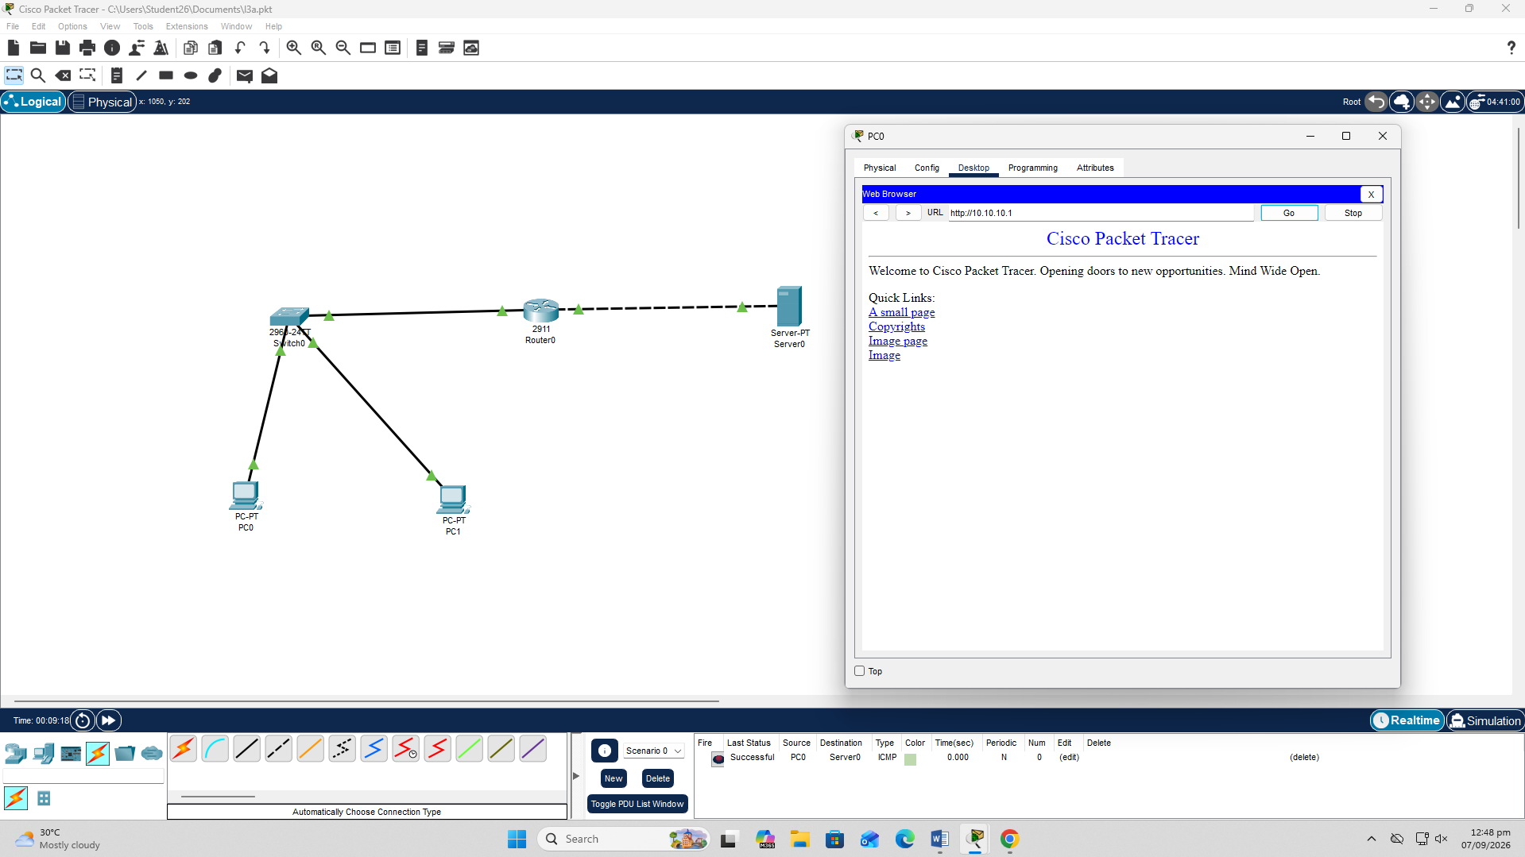
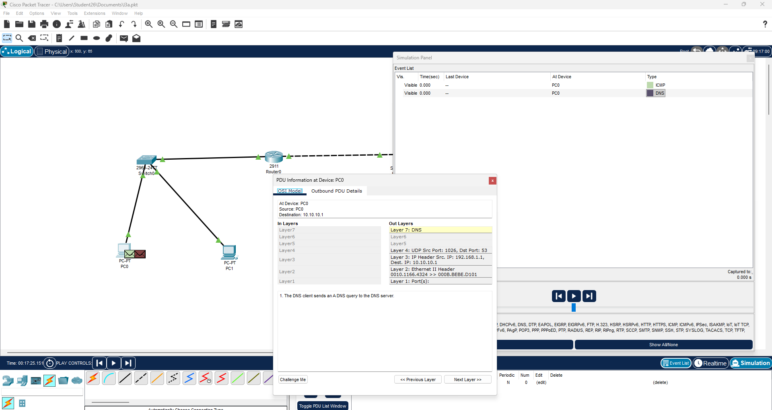

DNS Task:
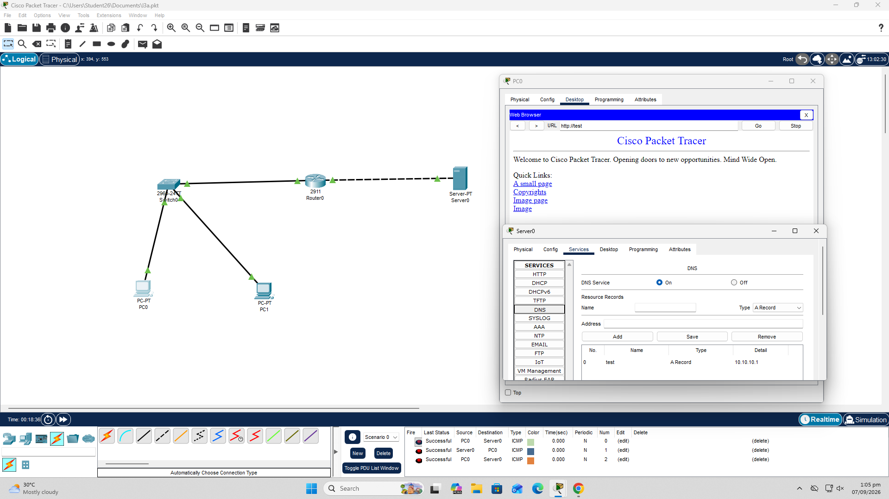

Question 2
1. What are the main differences between HTTP and HTTPS in terms of their purpose, port numbers, and the OSI layers involved in communication?
HTTP and HTTPS are both protocols used for communication between a client and a web server. HTTP transfers data without encryption and normally uses port 80, while HTTPS provides secure communication by using TLS encryption and normally uses port 443. In the OSI model, both operate mainly at the Application Layer (Layer 7), while HTTPS additionally uses TLS to provide security between the application and transport communication.
2. What is the conceptual difference between 4xx and 5xx HTTP status code classes? Explain what each class indicates and provide one suitable example of each.
The 4xx and 5xx HTTP status code classes indicate different types of errors. A 4xx error means there is a problem with the client’s request, such as an invalid URL or unauthorized access. For example, 404 Not Found means the requested resource could not be found. A 5xx error means the server encountered a problem while processing a valid request. For example, 500 Internal Server Error indicates an unexpected problem on the server.
3. What are the three major functions of a router at the Network Layer? Explain the concepts of path determination, packet forwarding, and network segmentation.
The three major functions of a router at the Network Layer are path determination, packet forwarding, and network segmentation. Path determination means the router selects the best route for a packet to reach its destination using its routing table. Packet forwarding means the router sends the packet through the correct outgoing interface toward its destination. Network segmentation means the router separates different IP networks or subnets and allows controlled communication between them.
4. What is the difference between an A Record and a CNAME Record? Explain the purpose of each and why they are used in real-world networks.
4. An A Record maps a hostname directly to an IPv4 address, such as fast-ai → 192.168.2.2. A CNAME Record maps one hostname to another hostname, such as www.fast-ai → fast-ai.example.com. A Records are used to connect hostnames to servers, while CNAME Records are used to create aliases so that multiple hostnames can point to the same destination without directly specifying the IP address for each one.
5. How does HTTPS provide secure communication between a client and a server? Explain the role of encryption, TLS, and digital certificates, and why HTTP does not provide the same level of security.
5. HTTPS provides secure communication by combining HTTP with TLS (Transport Layer Security). TLS encrypts the data exchanged between the client and server, helping prevent attackers from reading or modifying the communication. HTTPS also uses digital certificates to verify the identity of the server. HTTP does not provide the same security because it sends data without TLS encryption, making the communication more vulnerable to interception and modification.
6. A PC can access a server using its IP address (192.168.2.2) but cannot access it using its domain name (fast-ai). What does this indicate about the network or DNS configuration? Explain which DNS record or configuration could be responsible and why.
6. If a PC can access the server using its IP address 192.168.2.2 but cannot access it using the domain name fast-ai, this indicates a problem with DNS name resolution rather than basic network connectivity. The DNS server may be missing an A Record that maps fast-ai to 192.168.2.2, or the existing record may contain an incorrect IP address. The problem could also be caused by incorrect DNS server configuration on the PC. The most likely issue is that the DNS A Record for fast-ai is missing or incorrectly configured.

